This contract will be used for group evaluation at the end of class.

| **Subway Surfers** | |
| --- | --- |
| Tiffany Hatzidimitriu | tiffanyhatzi@gmail.com |
| Neerav Poriya | neeravporiyamum@gmail.com |
| Kshitij Sharma | ksharma67@gmail.com |
| Zo DiSanto | zodisanto14@gmail.com |
| Priyanka Kadam | 00priyankak@gmail.com |

# **Designated Logistics Roles for Meetings**

* **Kshitij Sharma** will manage the team for the first half of the project such as arranging meetings, and setting agendas.
* **Priyanka Kadam** will be the note-taker / organizer of digital assets for the first half of the project.
* **Tiffany Hatzidimitriu** will bring pen, paper, and other items to team meetings for the first half of the project.
* **Zo DiSanto** and **Neerav Poriya** will have more flexible roles, adapting to project needs for the first half of the project.

# **Communication Methods**

We will primarily communicate through Discord (https://discord.gg/hbzeXCca).

**Zo**

I prefer to communicate through Discord or WhatsApp messages on weekdays from 9-5. I am busy:

| **Mon** | **Tue** | **Wed** | **Thu** | **Fri** |
| --- | --- | --- | --- | --- |
| 12-2pm | 6-9pm | 6-9pm | 6-9pm | 12-2pm |

**Neerav /** Classes on: **Mon - Thur - Fri**

I prefer to communicate through Discord or WhatsApp on weekdays 12 - 5pm.

**Tiffany**

I prefer to communicate through Discord, text or WhatsApp on weekdays and weekends from 9-5. **Class/work MW 1 pm-4:30 pm, T 12am-10pm, R 12am-9pm, F 11am-3pm**

**Kshitij /** Classes on: **Mon - Wed - Thur**

I prefer to communicate through Discord or text on weekdays from 9-5.

**Priyanka**

I prefer to communicate through Discord or WhatsApp messages on weekdays from 9-5. I have classes on **Mon - Thursday 6PM to 9PM , Wed 9AM to 12noon**

**Team Schedule - A Visual:**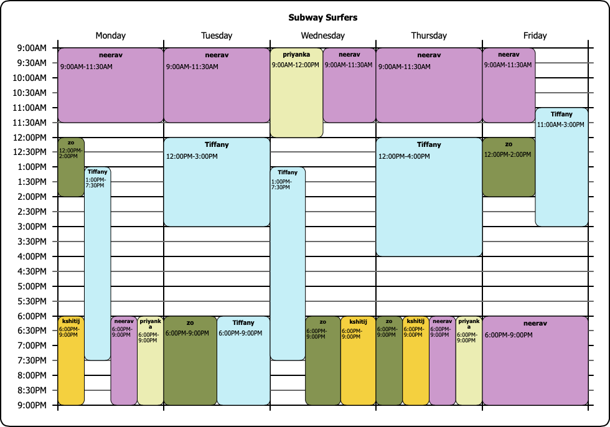

# **Meeting Logistics**

All members of the team agree to the following requirements for collaboration:

* We will meet every week on Tuesdays and Fridays 4pm-5pm over Zoom.
* All meetings must have a detailed agenda emailed out to all members before the start of a meeting
* All meetings must begin promptly on time. If a member is late, they need to message the group ahead of time.
* If someone wants to reschedule a meeting, they are responsible for coordinating the reschedule.
* There is one free pass or “miss” (for a meeting). Any more and this will impact their team evaluation at the end of the class.

# 

# 

# **Decisions and Conflicts**

In situations where the team cannot agree on the best way to move forward, everyone agrees to:

* We will vote on all decisions. Lets vote biweekly during meetings.
* If the team has spent 1 week on something without much progress, let's vote!
* Let everyone speak once before voting.

# **Deliverables**

You will need to discuss as a team what each person will be responsible for. Each member must agree to filling out their name, their tasks and the outputs of those tasks, and quality requirements. It is OK for more than one student (or all students) to work on the same thing.

For example, a task may be to create multiple sketches of paper wireframes, present Figma designs for a specific part of an app, or to interview 5 people for research.

Quality requirements may include time spent, level of fidelity (e.g., the designs must be at a level where the team feels it can be presented in the final presentation), or specific details on the delivery method (e.g., an interview recording along with a transcription).

The quality requirement is important because your teammates will evaluate you based on whether or not you meet your intended goals (e.g., amount of time spent on the project, high quality of output).

* As a team, we discussed thoroughly our individual responsibilities. We split our group into smaller groups to make the tasks easier to complete, then we met at an agreed-upon time to discuss what our smaller groups came up with. If there was some disconnect in what we agreed upon, we let every person convey their point and after that, as a team we voted and whichever had the most amount of votes is what we decided upon.

| Name | Task/Output | Quality Requirements |
| --- | --- | --- |
| Kshitij Sharma | Non-native new yorker persona | Persona should match the application goals and the interview results. |
|  |
|  |
|  |
| Personas vs jobs to be done compare and contrast | Compiled the result of the difficulties we faced at the time of creating both. |
|  |
|  |
|  |
| Did research | Asked research questions to both native New Yorkers and non-native New Yorkers. |
|  |
|  |
|  |

| Name | Task/Output | Quality Requirements |
| --- | --- | --- |
| Priyanka Kadam | Non-native New Yorker persona | Made sure that the persona goals matched with our jobs to be done result. |
|  |
|  |
|  |
| Jobs to be done framework | Made sure that the objective of the commuter was met with our end result. |
|  |
|  |
|  |
| Did research | Ask agreed-upon questions to at least two people (one native, one non-native). |
|  |
|  |
|  |

| Name | Task/Output | Quality Requirements |
| --- | --- | --- |
| Tiffany Hatzidimitriu | Compiling results of research | Reading over the results of collected research and compiling into one slide |
|  |
|  |
|  |
| Making native New Yorker persona | Persona should match application goals and research collected |
|  |
|  |
|  |
| Did research | Ask agreed upon questions to at least two people (one native, one non native) |
|  |
|  |
|  |

| Name | Task/Output | Quality Requirements |
| --- | --- | --- |
| Zo DiSanto | Making native New Yorker persona | Made sure persona matched application goals and research collected |
|  |
|  |
|  |
| Doing research | Ask agreed upon questions to at least two people (one native, one non native) |
|  |
|  |
|  |
| Defined research questions | Came up with questions to ask the subjects. |
|  |
|  |
|  |

| Name | Task/Output | Quality Requirements |
| --- | --- | --- |
| Neerav Poriya | Non-native New Yorker persona | Persona should match the application goals |
| It should cover the frustrations and motivations of the user with their basic info. |
|  |
|  |
| Process for collecting data | Based on the application selecting the method to collect the data. In our case Interview |
|  |
|  |
|  |
| Did research | Research the requirement based on the application. |
| Research should cover all the key points discussed in the meeting. |
|  |
|  |